Web Design Basics

Class 3 Assignment

Nino Mendolia

mendolin@newschool.edu

*PSAM 1028-D CRN: 3787 09/12/2017*

*PSAM 1028-C CRN: 2805 09/13/2017*

This week’s assignment is divided into two parts. The first has you build the basic page structure, the skeleton if you will, of your mid-term portfolio site.The second asks you to upload your progress to [GitHub.com](https://github.com/) and publish your draft pages to the web.

**Part 1:**

The first part of the assignment has you create the skeleton html pages you’ll be filling in with content as you progress through your first website.

1. Make a main folder for the week-3 assignment and create two sub-folders inside it labeled *css* and *img*.
2. Inside the week-3 folder, create a basic html document for each page you described in your site specification document from Assignment 2. This should include at a minimum:

-A home page titled *index.html*. This is where the purpose of the site is explained.

-Two *gallery* pages or two pages that relate thematically to your project site.

-An *about* page

-A *contact* page

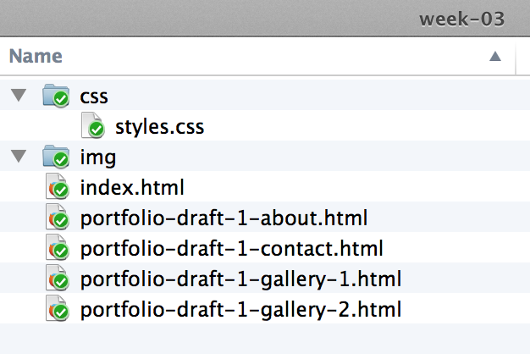

1. Create the navigation links for every page. Be sure to include a link to back to the home page of the site – that’s the *index.html* file in the week-03 folder above. As with all your pages for your site, test all your links carefully.
2. Remember to validate your HTML using the [html validation tool](https://validator.w3.org/) at w3.org.

1. Using the paint or drawing application of your choice (or using hand-drawing and scanning), create a wireframe schematic describing the basic layout and navigation for each page of your site. Don’t worry about the look and feel, just concentrate on the arrangement of the sections on each page. The *HTML and CSS* textbook has examples of a common layout:

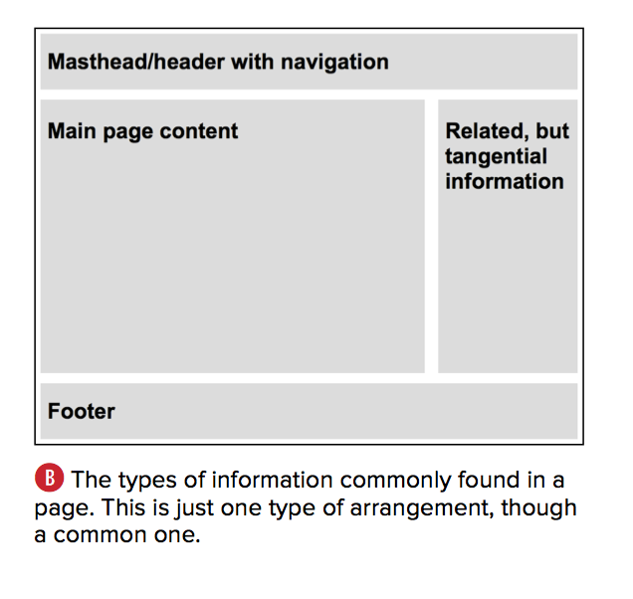

*Page 53*

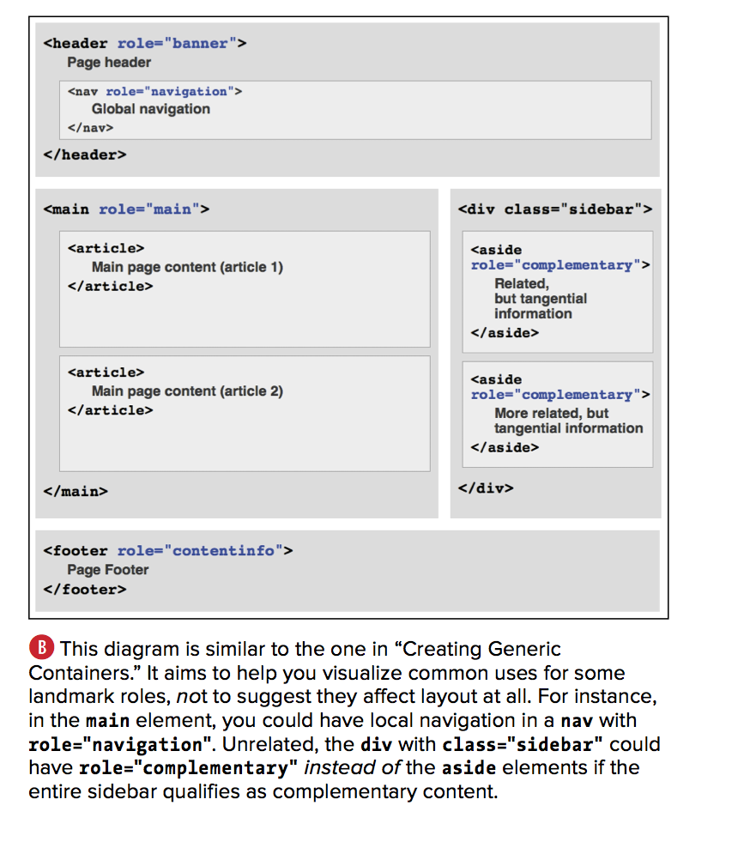

*Page 77*

The Web Style Guide has an excellent [page on the role of the wireframe](http://webstyleguide.com/wsg3/10-forms-and-applications/4-design-process.html) in the site design process. Read it prior to working out your own schematics for helpful advice.

Once they’re done save them as *.png* or *.jpg* files, then create and upload an html document containing the images to the week-03 folder. Call it something like “site-wireframe.html” Make sure make a link it to it on the index.html page of your site.

**Part 2:**

The second part of the assignment asks you to publish your skeleton pages to GitHub.com so you can share your progress with me and the rest of the class.

1. Go to the [GitHub](https://github.com/) website and sign up for a free account. Once you’ve logged in you should see a screen like the following:

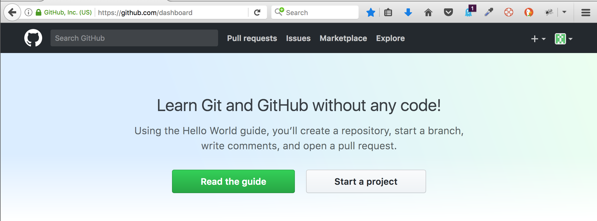

Click the *Start a project* button*.* This will allow you to create a *repository* on GitHub. Think of it as a remote folder that can, for our purposes, act as a web server.

1. On the *Create a new repository* screen, give your repository a name. Use your name, lowercase characters only and hyphens for spaces. Give it a short description, make sure it’s public and check the box next to *Initialize this repository with a README*. Then click the Create repository button.

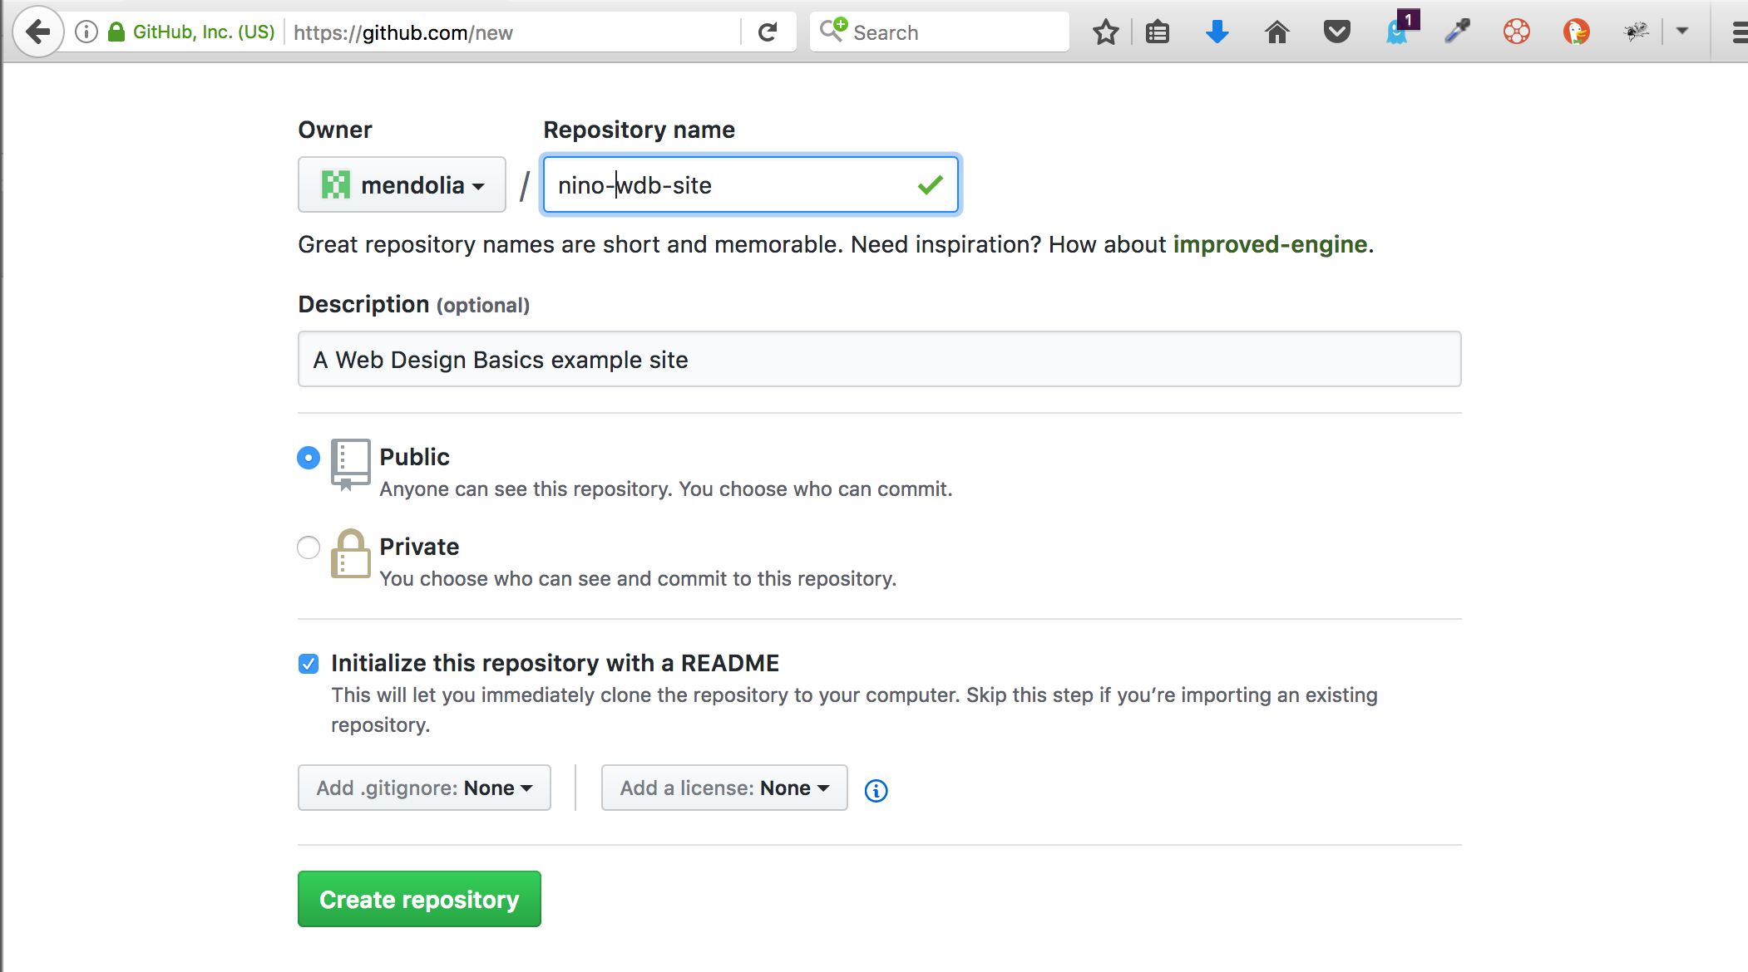

1. Once on your repository page, click the *Upload Files* button to copy the Assignment 3 site files from your machine to your GitHub repository.

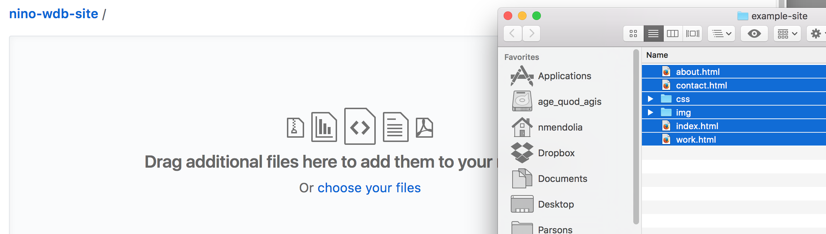

Click the *Commit* button at the bottom of the screen to save the uploads to the repository. The resulting screen should look something like this:

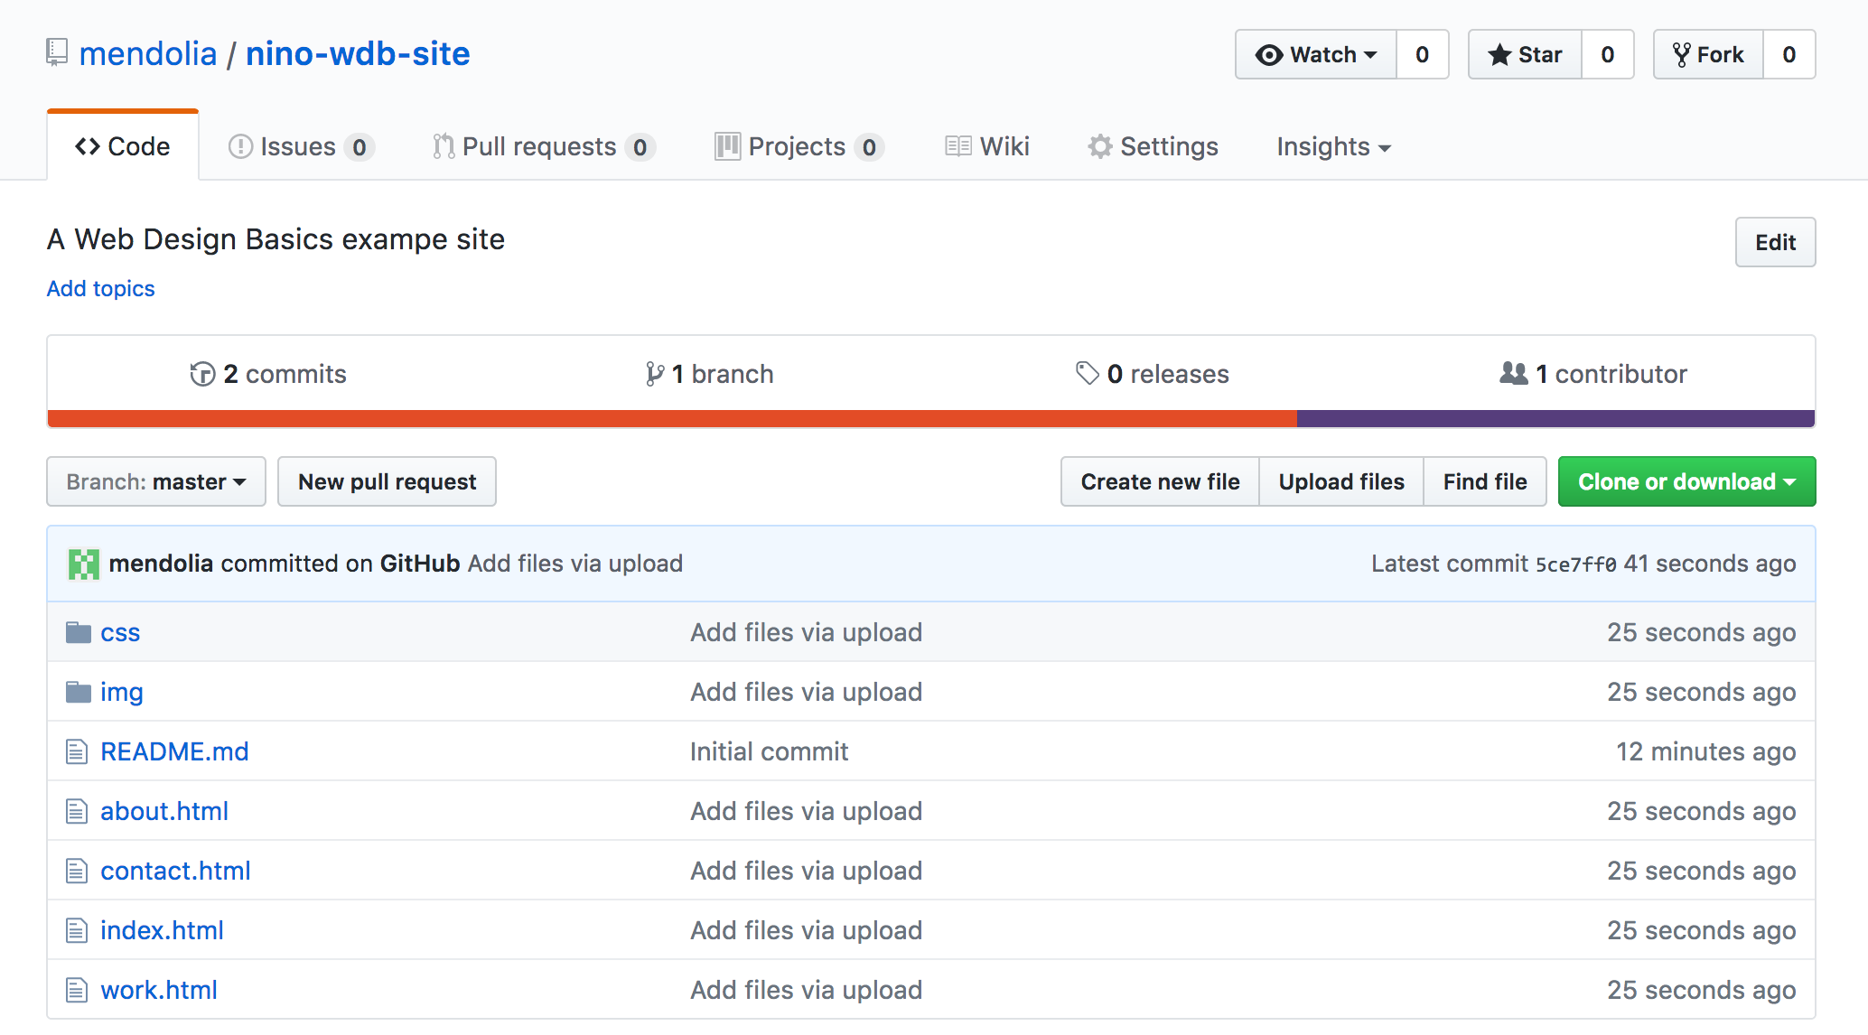

1. The last step is to make the contents of this folder reachable via a web URL. Start by clicking *Settings* near the top of the window. Next, on the *Settings* screen scroll down to the *GitHub* *Pages* section. Under the *Source* category choose *master branch* and click *Save*. The screen will update with the public GitHub Pages URL for your site. Visit your site, then bookmark that URL.

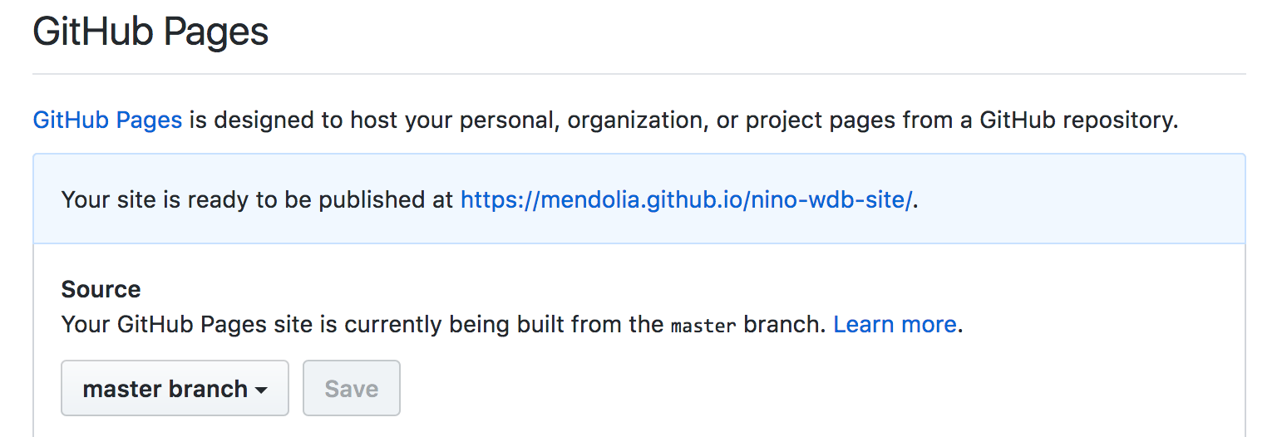

Congratulations! You’ve published your site to the web. Send me the URL as part of Week 3 Canvas submission.

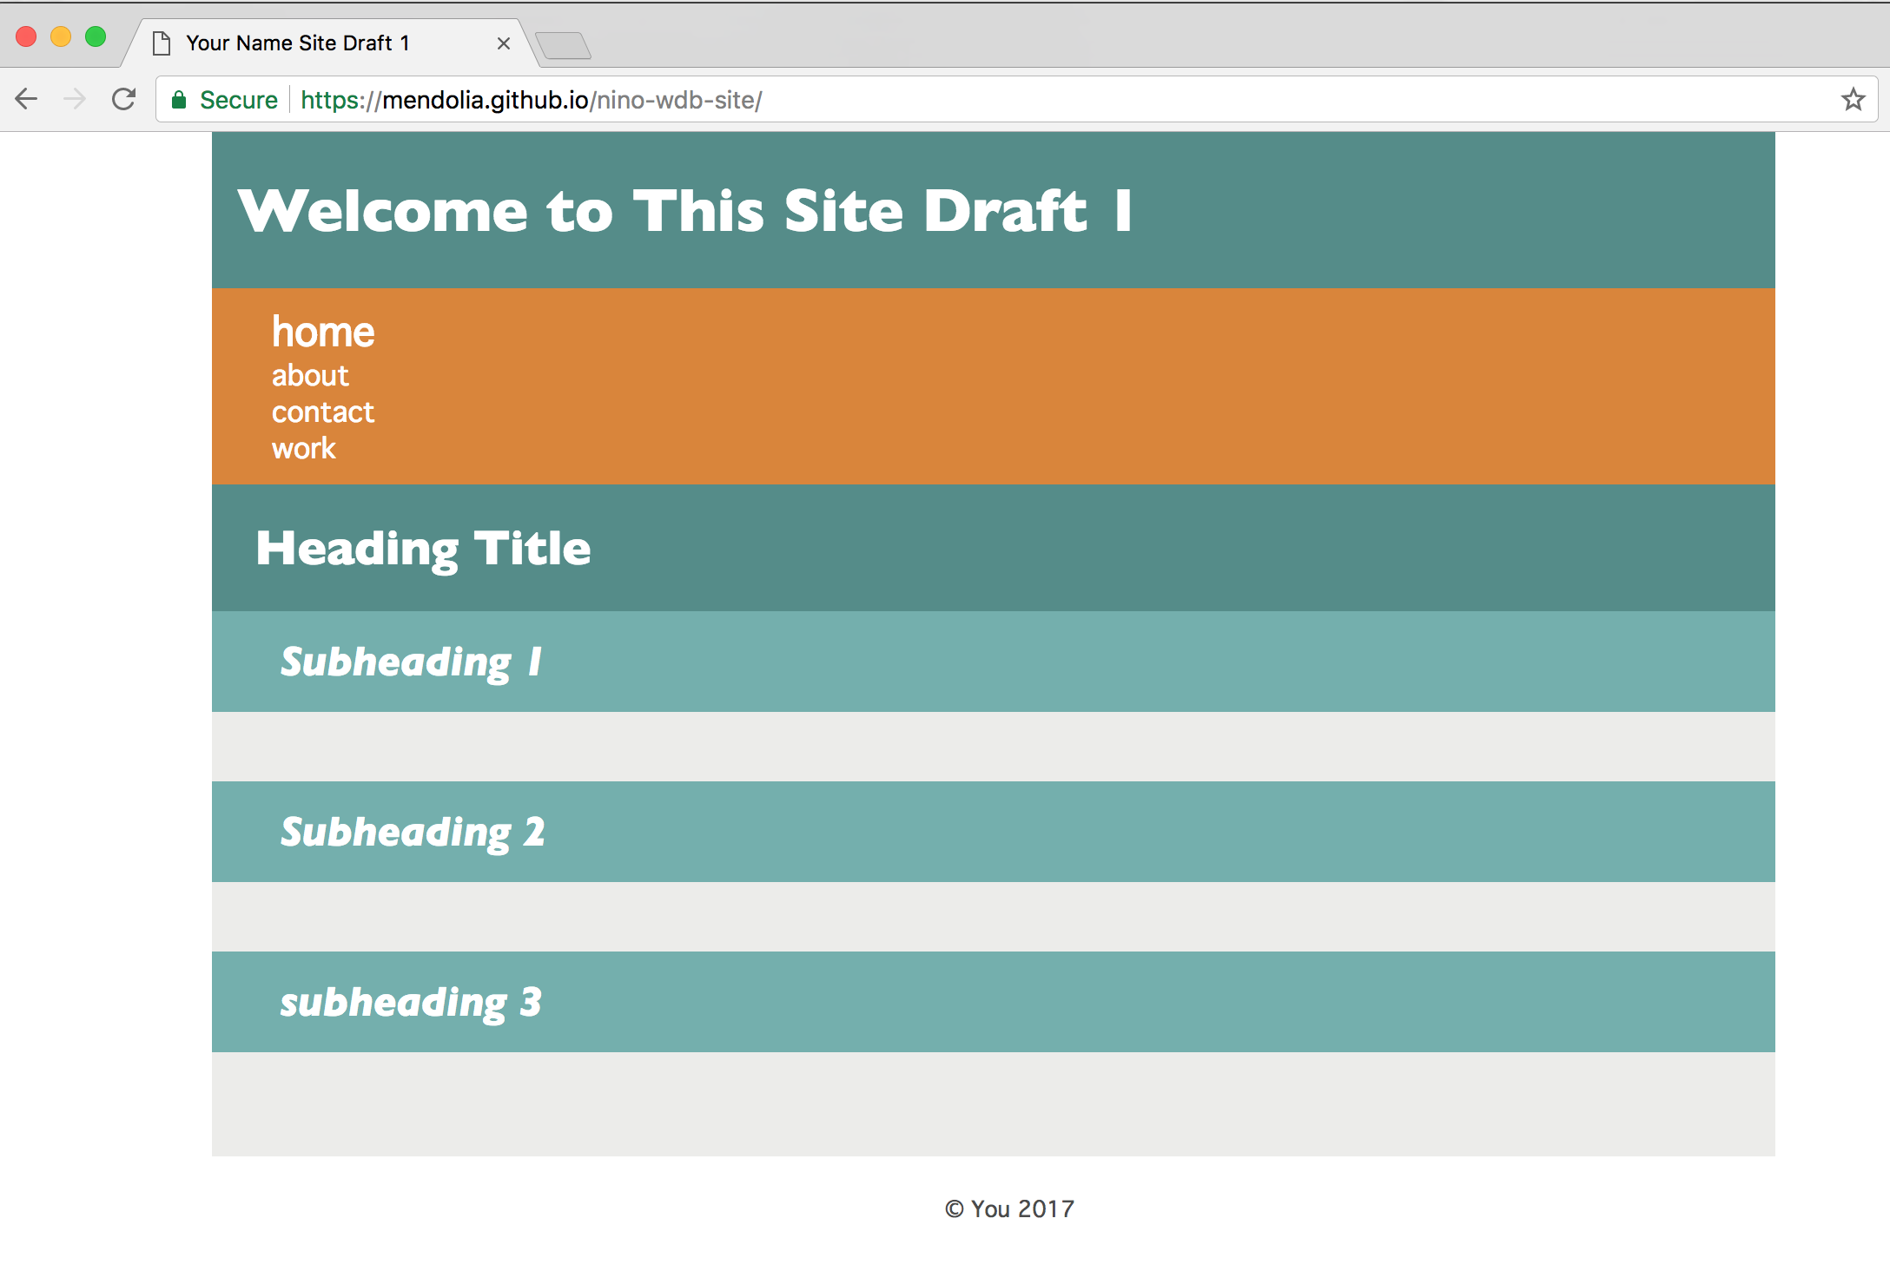

As always, please send me an email if you have any questions.

The due dates for assignment 3 are as follows:

For CRN 3787, Section D, Assignment 3 is due 09/19/17 by 12 Noon.

For CRN 2805, Section C, Assignment 3 is due 09/20/17 by 9 AM.

Readings for next Class:

*HTML and CSS: Visual QuickStart Guide (8th Edition)*

*Chapter 5: Images*

*Chapter 6: Links*

*Chapter 20: Testing and Debugging Webpages*

*Chapter 21: Publishing Your Pages on the Web*